

Republic of the Philippines
Department of Education
National Capital Region
DIVISION OF QUEZON CITY SCHOOLS
Quezon City, Metro Manila

SECOND PERIODICAL TEST
MATHEMATICS IV
SY 2009-2010
DIRECTIONS: Write the letter of the best answer on your answer sheet. All answers must be simplified with the correct unit. Use scientific calculator when necessary.

- Which of the following relations represents a function?
A. { (x,y)/ y = x } C. { (x, y)/ y > x }
B. { ( x, y )/ x = y² } D. { ( x, y) / x + y² = 9 }

2. . If f(x) = 3x + 5 and g(x) = x³ + 2, then what is f(x) − g(x) ?
A. 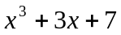 C. 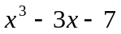
B. 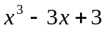 D. 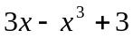

3. Which one of the given set of ordered pairs is NOT a function?
A. { (2, 3), (3, 4), (4, 5), (5, 6)} C. { ( −2, 4), (−1, 1), (0, 0), (2, 4)}
B. { ( 1, 2), (3, 4), (3, 5), (4, 6)} D. { (3, 3), (4, 4), (5, 5), (6, 6) }

4. Given f(x) = 3x + 5 and g(x) = x³ + 2, what is the value of f [ g(2) ] ?
A. 29 B. 35 C. 41 D. 53

5. What is the range of the function y = 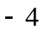x² 1 ?
A. y - 4 B. y - 4 C. y ≥ - 1 D. y 1

6. If f(x) = 3x + 5 is subtracted from g(x) = x³ + 2, what is the result ?
A. – 2x² – 3 B. 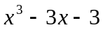 C. D. 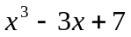

7. Which of the following are the zeros of the function y = ( x 5 )( x – 4 ) ?
A. B. C. D.

8. What is the value of g ( − 2 ), if g(x) = 25x – x ² .
A. – 46 B. 46 C. – 54 D. 54

9. Which of the following describes the graph of a constant function?
A. y = 5 B. y = x C. x = 5 D. y = x²

10. What is the domain of the function f(x) = 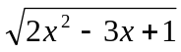 ?
A. 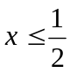 or 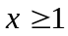 C.  < x < 1
B. 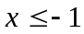 or 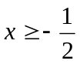 D. x 1
11. What is the range of the function defined in number 10?
A. 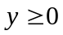 B. y > 0 C. all real numbers D. positive integers

12. A line passes through the origin. If its slope is – 7 , what is its equation ?
A. y = 7x B. y = ─ 7x C. y = x + 7 D. y = x ─ 7

13. What is the line of symmetry of the graph of the quadratic function y = x² – 3 x – 10 ?
A. x = B. x = 3 C. x = D. x =
14. Which one is the vertex of the quadratic function defined in #13?
A. ( 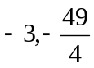) B. ( 3, 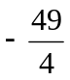) C. ( 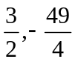) D. ( 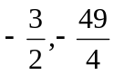).

15. What is the remainder when P(x) = 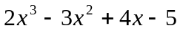 is divided by (x + 1)?
A. 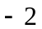 B. 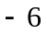 C. 0 D. −14

16. If f(x) = 3x – 7 , and 3 ≤ x ≤ 8, what is the range of values of f(x)?
A. 2 ≤ f(x) ≤ 17 B. 2 ≤ f(x) ≤ 16 C. 2 <f(x) ≤ 17 D. 2 < f(x) < 17

17. What must be the numerical coefficient of x in 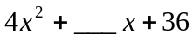 to make it a perfect square
trinomial ?
A. 8 B. 12 C. 20 D. 24

18. Which of the following is NOT a quadratic function?
A. 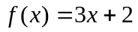 C. g(x)= ( x – 4 )²
B. 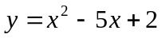 D. 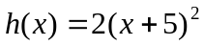

19. What is the product of (2x + 5) and (3x – 7 ) ?
A. 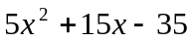 C. 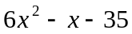
B. 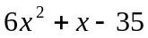 D. 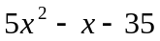

20. When factored, what is the solution set of 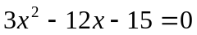?
A. { 1, 5 } B. { 1, 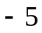} C. { 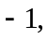 5 } D. { 5 }

21. What equation is obtained when 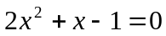 is solved using completing the square?

A. ( x + )= 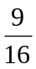 C. ( x )=
B. ( x + )= D. ( x )=

22. What values of x will make the quadratic equation in #21 true?
A. { } B. { } C. { } D. { }
23. What term is given to the abscissa and the ordinate of a point ?
A. x-value B. y-value C. coordinates D. function value

24. Write the equation 3x − y = 5 in slope-intercept form.
A. y = 3x – 5 B. y = 3x + 5 C. y = −3x – 5 D. y = −3x + 5

25. Which of the following defines a linear function?
A. C. g(x)= ( x – 4 )( x – 4)
B. D.

26. What binomial of lowest degree must be multiplied to 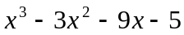 to make it a polynomial
with perfect root?
A. x+5 B. x – 5 C. x – 1 D. x + 1

27. A relation in which each element of the domain is paired with exactly one element of the range.
A. one-to-one B. many-to-one C. one-to-many D. many-to-many

28. The relation whose equation is ( x + 1)² + ( y – 5 )² = 4 is
A. one-to-one B. many-to-one C. one-to-many D. many-to-many

29. Describe the roots of 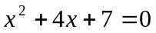.
A. imaginary B. real and equal C. rational and unequal D. irrational

30. What is the slope of a line parallel to the line whose equation is 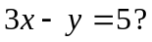
A. 3 B. −3 C. D.

31. What is the equation of the line described in #30 if it passes through the point ( 2, − 3 ) ?
A. 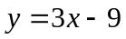 B. 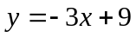 C. 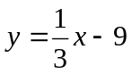 D. 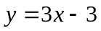
32. Find two consecutive positive even integers whose sum is 38.
A. 12 and 26 B. 18 and 20 C. 14 and 24 D. 16 and 22

33. What must be the value of c in 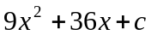 to make it a perfect square trinomial ?
A. 12 B. 24 C. 36 D. 40

34. What is the vertex of the parabola defined by the equation 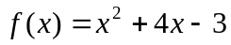?
A. 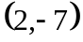 B. 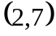 C. 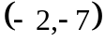 D. 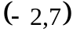

35. If ( 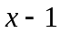) is a factor of the polynomial x² – 2x + 1, which one is the other factor ?
A. (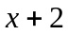) B. (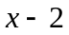) C. (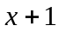) D. ( x – 1 )

36. If f(x) = 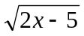, what is its domain ?
A. 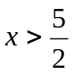 B. 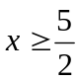 C. 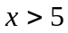 D. 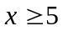
37. What is the range of the function defined in # 36?
A. 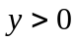 B. C. 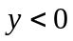 D. 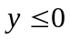

38. Find the equation of a quadratic function whose zeros are 5 and – 3 .
A. 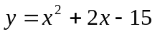 C. 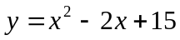
B. 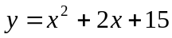 D. 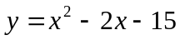

39. The sides of a rectangular field are of lengths 3x meters and 2x meters. What is the perimeter of
the field in meters?
A. 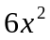 B. 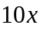 C. 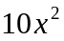 D. 5x

40. What is the point of intersection of 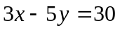 and the y-axis?
A. 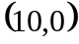 B. 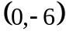 C. 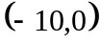 D. 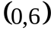

41. If f(x) = 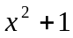 and g(x) = 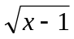, what is the value of ( f o g ) (1)?
A. 0 B. 1 C. – 1 D. 2

42. Let f 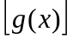= 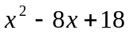, and g(x) = x – 4 , what is f(x) ?
A. 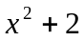 B. 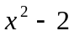 C. 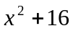 D. 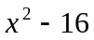

43. The graph of the function P(x) = 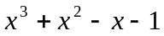 is tangent to the x-axis at what point ? ?
A. ( 1,0 ) B. ( 1, 0 ) C. ( 2, 0 ) D. ( 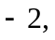0 )

44. What are the zeros of the polynomial function defined in number 43 ?
A. { 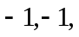1 } C. { 0, 1, 2}
B. { 0, −1, 1} D. { −1, 0, 2 }

45. What should be the value of k so that ( x + 1) is a factor of 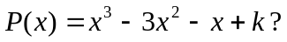?
A. 2 B. 3 C. 4 D. 0

46. Give the coordinates of a point which is 3 units below the x-axis and 4 units to the left of the y-axis.
A. 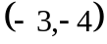 B. 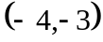 C. 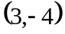 D. 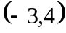

47. The dimensions of a rectangular box are (x + 1) m by (x 1) m by ( x + 2 ) m, respectively.
What is the volume of the box in cubic meters?
A. 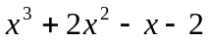 C. 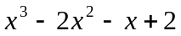
B. 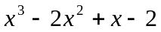 D. 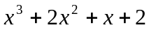

48. A ball is thrown upward according to the equation f(t) = 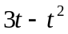, where t is in minutes.
How long does it take the ball to reach the ground ?
A. 1 sec B. 2 sec C. 3 sec D. 4 sec

49. How high does the ball in number 48 go?
A. 2 units B. 2.25 units C. 3 units D. 3.25 units

50. How long does it take the ball to reach its highest position before it starts to move down?
A. 1 sec B. 1.5 sec C. 2.5 sec D. 3 sec

Key to Corrections - Mathematics

I II III IV

- 1. 1. 1. A
- 2. 2. 2. D
- 3. 3. 3. B
- 4. 4. 4. B
- 5. 5. 5. D
- 6. 6. 6. B
- 7. 7. 7. A
- 8. 8. 8. C
- 9. 9. 9. A
- 10. 10. 10. A
- 11. 11. 11. A
- 12. 12. 12. B
- 13. 13. 13. C
- 14. 14. 14. C
- 15. 15. 15. D
- 16. 16. 16. A
- 17. 17. 17. D
- 18. 18. 18. A
- 19. 19. 19. B
- 20. 20. 20. C
- 21. 21. 21. A
- 22. 22. 22. A
- 23. 23. 23. C
- 24. 24. 24. A
- 25. 25. 25. A
- 26. 26. 26. B
- 27. 27. 27. A
- 28. 28. 28. C or D
- 29. 29. 29. A
- 30. 30. 30. A
- 31. 31. 31. A
- 32. 32. 32. B
- 33. 33. 33. C
- 34. 34. 34. C
- 35. 35. 35. D
- 36. 36. 36. B
- 37. 37. 37. D
- 38. 38. 38. D
- 39. 39. 39. B
- 40. 40. 40. B
- 41. 41. 41. B
- 42. 42. 42. A
- 43. 43. 43. B
- 44. 44. 44. A
- 45. 45. 45. B
- 46. 46. 46. B
- 47. 47. 47. A
- 48. 48. 48. C
- 49. 49. 49. B
- 50. 50. 50. B

